Assignment 4 (October 3 - October 8)

1. Find 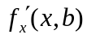, if 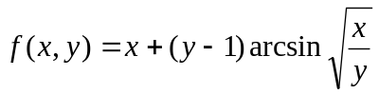.
2. Find all partial derivatives of the following function: 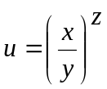.

3. Find all partial derivatives of the following function: 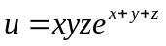.

4. Find the total differential of the following function: 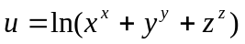

5. Use differentials to approximate each of the following:
a) 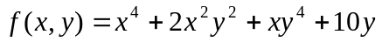 at x=10.36 and y=1.04;
b) 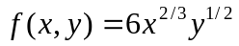 at x=998 and y=101.5;
c) 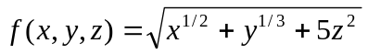 at x=4.03, y=7.95 and z=1.02.

